The Lingering Danger We have Failed to Observe

Dr. Tesfa G. Gebremedhin

West Virginia University
Every country has its own customs which have been passed down for generations in the form of traditional law, order, rules, and norms. Nowadays, every Eritrean family has a significant number of relatives that live in diaspora. Despite the lack of actual data, it is not an exaggeration to state that one third of the total Eritrean population live in countries outside of Eritrea. Although the Eritreans living in diaspora are composed of persons of all ages, the great majority are the young ones who really need guidance and support from respective communities and religious institutions. Our children, in particular, who were born and raised in the varied cultures of different nations, cannot even communicate nor understand each other. Many of them cannot carry a conversation with their grandparents, cousins or blood-relatives that were raised and are living at home in Eritrea. Many of our children cannot speak any of the Eritrean languages and do not know or understand any of our cultural practices. It is evident that our children can learn the meanings of our cultural heritages and ethnic identity and so can become more involved in their ethnic cultures. Our cultural practices can also provide our children with wonderful opportunities to appreciate our traditional social values and to acquire our indigenous knowledge. However, it is really an embarrassment to observe that our involvement and engagement in our own traditional cultural activities in our households, communities and religious institutions is far below our expectations. In most instances, our activities are confined to folk dances. Consequently, we are losing our cultural heritages and social values little by little, in the manner suggested by the following story of the ‘Boiling frog’.
A tale, which might not be actually true but provides a great message and a powerful wisdom, has been narrated that if you put a frog into a pot of boiling water, it will leap out right away to escape danger. However, if you put a frog in a kettle that is filled with water that is cool and pleasant, but if you gradually heat the kettle until it starts boiling, the frog will not become aware of the threat in which it finds itself until it is too late. The frog could not jump out of the kettle because it would not be able to perceive the lingering danger until the frog was cooked to death. The frog's survival instincts are geared towards detecting sudden changes. In similar example it was observed that every year, the local well had an inch less of water in it. Any person in the right mind might realize that there is a problem, if there is suddenly NO water in the well. But, a slowly decreasing water level of the well might not be an obvious crisis to observe until it is too late. The Boiling frog story in particular, is a widespread anecdote which is generally told in a metaphor to make people aware of the danger of slow, lingering changers which can lead to horrible consequences. It is a warning to keep people paying attention not only to obvious threats but to more slowly developing and lingering danger as is the case with the frog being slowly boiled alive to death. What is happening with our cultural norms and social values?
Though the story is often used as a metaphor, the moral of the story reflects our inability or unwillingness to react to the significant changes that have been occurring gradually in our households, communities or religious institutions with regard to our quickly vanishing traditional heritages, cultural practices and social values. It brings great pride to know that we have a beautiful culture. It is a culture that urges us to “honors thy father and thy mother”. It is a culture that cherishes ‘the extended family system’ urging to help siblings, relatives and friends in time of adversity. It is a culture that encourages us to be our brother’s and sister’s keeper. It is a culture that urges us to ‘love thy neighbor as thy self’. It is a culture that enables us to consider the norm that “It takes the whole village to raise a child”. It is a culture that embraces friendship and intimacy and helps us to deal animosity and hostility with patience. It is a culture that enables us to respect the elders, teachers, and religious leaders with dignity. It is a culture that advocates social justices and observes traditional law, order, rules, and norms with integrity. It is a culture that enables us to have faith and to worship one God. We have inherited and received such a wonderful culture from our parents on silver plates. We have the utmost obligation to pass down this culture to our children and grandchildren.
In the process of our engagement in our cultural activities, if we see a family breaking down, we have the moral obligation to get involved in creating peace and harmony between the spouses before they go to court. We cannot say “I am not my brother’s or sister’s keeper” because every one of us are his/her brother’s and sister’s keeper. If we get involved as our elderly parents did in such situations, we will be able to reduce the ever increasing number of single parents due to broken homes. If we observe a family having problems with their children (teenagers), we cannot say “It is none of my business” to interfere in somebody’s problem. It is everybody’s business because, according to our traditional customs, rules and norms, “It takes the whole village to raise a child” a way of thinking which has been practiced in Eritrea for centuries. If we are involved in social intervention within our communities, we can save so many children resulting from drugs and alcohol abuse, teenage pregnancy, running away from home, suicide attempts, dropping out from school, joining the gangs, and becoming homeless. Thus, the boiling frog story is a story that is used to illustrate how we might fail from making shipwreck of our lives, if we do not identify and address the gradual changes in our households, communities and religious institutions. Perhaps, we have just been waiting for danger to erupt suddenly, but unfortunately those problems which develop slowly and unnoticeably are erupting before our eyes and we are now suffering their undesirable consequences. In other words, we have become the weakest link in failing to make the connection between our parents and our children. We have become unable to pass on the legacy of our parents to our children with great pride. We have failed in preserving and sustaining our cultural practices and traditional social values when we started munching hamburgers and French fries. If we don’t just wake up and do the right thing, subsequently, our precious cultures will soon disappear and become extinct amongst our current generation. Our children will then be forced to adapt the cultures and values of the new countries in which they were born and have grown up. Our children will be called Australians, or Europeans or Americans, or Asians, or Arabs of African origin without ethnic cultural heritages and social values to identify them as Eritreans in diaspora. What else do we expect to happen?
Whenever there is accountability and the assuming of responsibility the results are usually more effective. Perhaps it would be wise to remind ourselves that each of us is accountable and eventually will stand before our parents who are in heaven to give them an account of how we have lived in Diaspora and how we slowly lost our cultural heritages and ethnic identity piece by piece. We will be asked by our former ancestors how and under what conditions we have left our children behind. It should be clear that children are our most valuable treasure in our life. They are the only living messages we send to a future time we will not be able to see. The message we would like to convey to the next generation should be based upon our cultural heritages and ethnic identity. We should be aware the fact that what a child usually does not receive from the parents, the child seldom later gives to the next generation. Once a child is born, we need to raise that child in our customs, rules and norms constantly providing confidence, honesty, respect, discipline, faith, integrity and above all love, which binds all of us together. We affect generations to come with the kind of decisions and actions we make today in our households, communities and religious institutions. Each generation should function better than the previous generation. Thus, our children should have a strong legacy passed on to them from their parents. We have to be the mighty rock for their protection and the solid fortress where they can find safety and security. However, if we have broken families, dysfunctional communities and disintegrated religious institutions, we will not be able to become the mighty rock and fortress for our children. We, particularly the Eritrean scholars and professionals, need to wake up and be the role model in actively participating in building our communities and religious institutions to give our children an anchor to hold on, to deliver them from the problems of life, and to raise them to be responsible and accountable to the next generation. Our generation is defined by the kind of communities we belong to and identified by the kind of culture we are endowed. We should all exercise our God-given gift of life to build our communities which cherish our cultural practices and social values with great hope for the kind of life we can prepare for our next generation – our beloved children and grandchildren.
High-Tech and Tradition at Work; No Conflict of Interest (check below)
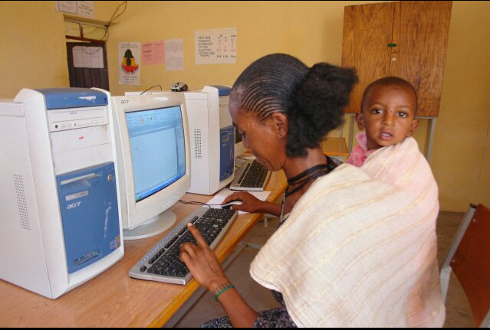
Some of us wrongly think and believe that our cultural practices and social values do not complement with modern life. However, the image above boldly demonstrates that high tech and tradition can co-exist and advance in harmony and peace. In fact, it has been observed with people in other countries like the Chinese, that tradition and modern life complement each other. When it comes to preserving their cultural heritages and respecting their ethnic identity, there is no difference between a Chinese from the home country and a Chinese who lives in diaspora. The only difference that comes between the two Chinese is the separate locations of their residences. Otherwise, both Chinese practice the same cultural norms and cherish the same traditional social values in their respective locations by embracing modern life. A Chinese anywhere in diaspora has an obligation to preserve, sustain and advance the Chinese culture and tradition in subsequent generation. Likewise, if we have the will power and passion to do the same, we can make things happen in our own social fabrics. However, we need first to make peace with ourselves and love one another and then actively involved in solving the quarrels and problems that have become the cancer in our broken households, dysfunctional communities and disintegrated religious institutions. If we just do our best, God will do the rest. `

