The Eritrean Association in greater Seattle
Invites you to Celebrate with us
The International Women’s Day 2010

Program:- Cultural Show by Talented Seattle Musicians
Date/Time:- Saturday March 6, 2010 At 6:00 PM
Place:- Eritrean Association in Greater Seattle
1528 Valentine Place, Seattle

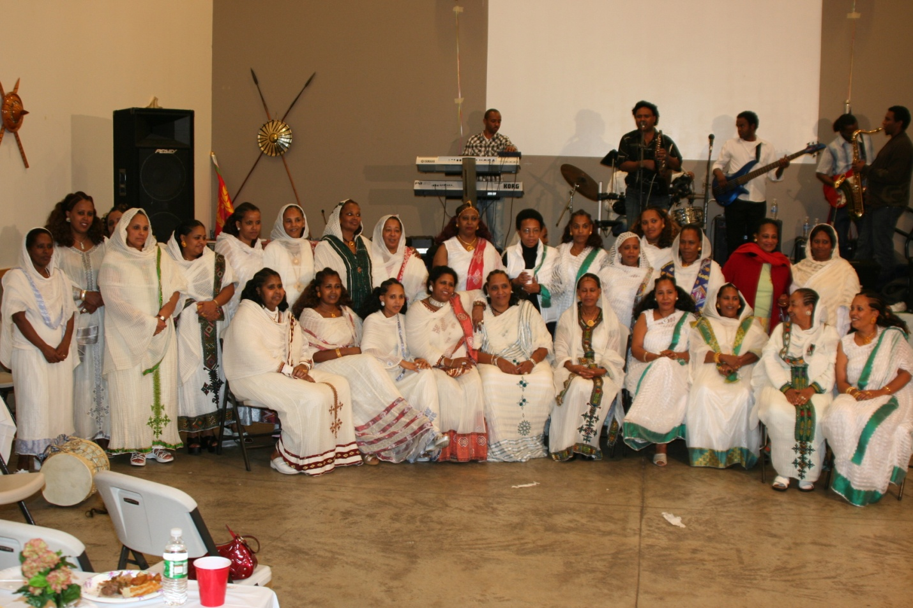
ማሕበረኮም ኤርትራ ስያትልን ከቢኣን
ከምቲ ልሙድ ብምኽንያት ኣህጉራዊ መዓልቲ ደቀንስትዮ 8 መጋቢት
ዓቢ ናይ ባህሊ ምሸት ኣዳልዩ፡ ንኾሎም ኤርትራዊያንን ፈተውትን ሓቢሮም
ምሳና ከምስዩ ብኽብሪ ይዕድም።

መደብ ባህላዊ ምሸት በቶም ወናማት ንይ ስያትል
ዕለትን ግዜን ፥ ጉንበት 6, 2010 ሰዓት 6፡00 ኣይ ምሸት
ቦታ፥ ማበረኮም ኤርትራ ስያትል ከባቢኣን
1528 Valentine Place, Seattle Washington

ብደሓን ምጹ

