On March 2010 Dr. Tesfay Aradom conducted a seminar at the Eritrean Community Center in Winnipeg on a topic “Social Challenges in the Eritrean Diaspora”.
Dr Tesfay, a psychologist from Boston Massachusetts with extensive experience on the impact of immigration and its Psychological Consequences.
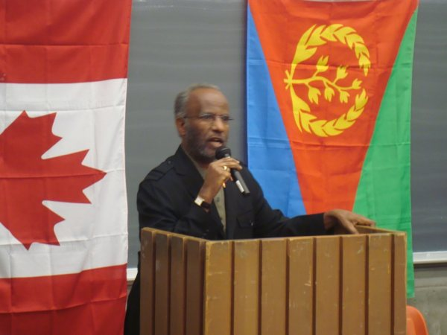
The Eritrean community in Winnipeg welcomes every year several hundred of newcomers (to Canada) and runs regular intergenerational classes and Community Based Education to strengthen families and assist them with the challenges of resettlement and transition. Dr Tesfay’s presentation was conducted under an atmosphere of intense interest from participating families.
The psychological consequences and implications on Eritrean identity were explored after a brief description of the historical context was given. Factors affecting psychological outcome, recommendations for practical interventions to facilitate adaptation, personal and community growth were explored and discussed.
The multidimensional, complex psychological process and the impact on an individual’s struggle for identity and personal development, were also analyzed and examples from various experiences were presented in an effort to give a picture of the social challenges, that the Eritrean Diaspora faces in different environments.
Traumatic psychosocial experiences and reactions, the more complicated and challenging youth process, intergenerational issues , conflict and reconciliation between two cultures were among the few factors, among many, that were elaborated.
Differences among adults, youth and children, impact of parental coping mechanisms on youth and children and the factors that can comply to create a safer, more stable and predictable environment were discussed.
The role of stable communities and the development of communities with sustainable functioning was also a part of the final closing.
The Eritrean Community in Winnipeg was privileged to have this excellent seminar that received high scores on the participants’ evaluation. Thank You Dr Tesfay for your kindness, time and wealth of knowledge shared with our community members
Thank you Dr Tesfay Aradom from Winnipeg Canada

