Expansionist Ethiopia has run-out of tricks and tricksters.
December 28, 2011
By Esayas Temesgen
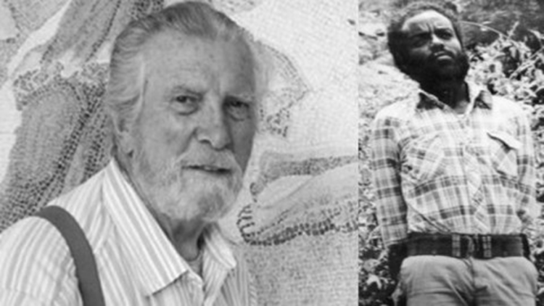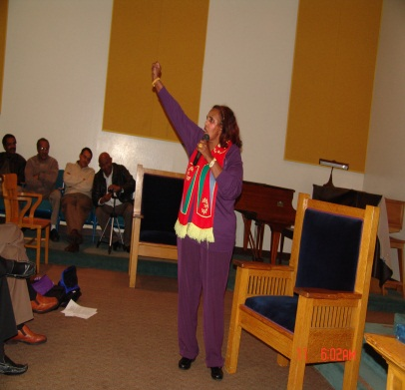
The picture above: left - seating is Paul Henze an American pseudo-intellectual that made a career for himself by spewing hate and distorting history. He was one of those arrogant, who think they know better for Africa than its own Sons and daughters.
Center - standing is Prime Minister Meles Zenawi the current leader of Ethiopia, in his gorilla garb [Trotskyite] before he turned to a war lord of the Horn of Africa.
Far right- is an Eritrean American woman with a scarf made of Eritrean flag around her neck, at a meeting in San Jose, Ca. U.S.A on December 11, 2011 making a passionate speech to the audience condemning Expansionist Ethiopia recent scheme to tint Eritrea as a terrorist.
Paul Henze is neither honest intellectual nor historian, but a miscarried CIA contact and propagandist of Ethiopia, who operated as chief adviser for the alternating Leaders of that nation.
He was by far the worst enemy of Eritrean sovereignty who has singlehandedly lobbied and campaigned aggressively in the USA. He planted a cancerous anti Eritrea seed for the duration of the armed struggle.

Paul Henze was a mentor to Ethiopian “intellectuals” more than he was an adviser to USA policy makers. He has written many Books on Ethiopia [his version of Ethiopia] made hundreds of lectures and interviews to newspapers and internet Bloggers; he has toured various countries - to lobby for Ethiopia; No Ethiopian intellectual can much what he has done to damage sovereign Eritrea.
Nevertheless, all his three decades conspiracy was flashed down to the toilet, when Eritreans under the leadership of the EPLF repealed the invading Ethiopia army by pushing it back to its capital - Addis Ababa.
Paul Henze interviewed Meles for five hours on their preliminary contact in Washington D.C. on April 3, 1990, just before the TPLF forces entered Addis Ababa. About his Marxist back ground; his relation with EPLF; his stands on Eritrean independence; his personal relation with president Esayas Afewerki of Eritrea and his prospect of post Eritrean independence etc.... a kind of background check before he meets US officials and lawmakers to plea for recognition and some help. [Here is where his Trojan horse role commenced. And Paul assumed the rank of confidant]. paul-henzes (2011/05) conversations-with-meles- zenawiaddisvoice.com.
In this interview, Paul rubs - in about land to Meles, he wanted to know his stand on commercial farming and foreign capital investment on farm land, setting him up - for the controversial massive fertile land grab by foreign countries in Ethiopia. That recently enticed a global uproar.
Paul Henze defies logic with his ridicules narrow minded anti Eritrea propaganda he tried to rewrite history with his lies. He was very sensitive; he gets upset whenever his act of defamation of Eritrea is exposed. He can’t stand any positive coverage of Eritrean history particularly through the western media, he gets nervous. He makes sure nobody write or speak the truth about Eritrea, mainly in the USA and in the West.
Here are sample excerpts of his many works, how his weird idea of Eritrean war for liberation and his behind the seen futile spin before the court’s decision on the border conflict.
“Nonetheless, there are a few large non-facts that deserve to be disposed of. Chief among these is the supposed thirty-year struggle for Eritrean liberation from Ethiopian rule. It is this idea which fueled a marked bias for Eritrea in the leading media, including such highly responsible newspapers as the Wall Street Journal and Washington Post in the U.S. and the Economist in Britain. The reality is that the skirmish between a Muslim group and a small Ethiopian army unit, in 1961, was scarcely the beginning of a « thirty-year struggle. » Paul Henze (Nov 15, 2007) “The question on Eritrea” haerel.org
This is a revelation how notoriously he was engaged in disinformation campaign at the inception of the Eritrean struggle: to ridicule, frustrate and attack it. It is a kind of clue where the leaders of that country were getting ideas from. Religion has been used to get sympathy from the west and Israelis for expansionist Ethiopia. It was also used as weapon to create ethnic strife within Eritrea.
Interviewed by Robert Wiren of Les nouvelles d'Addis (December 28, 2001)
LNA. – Do you believe that serious tensions could happen on the northern border despite existing peace agreements and despite international mediation?
PH. –. Nowhere was Eritrean behavior worse than in the Irob region of northeastern Tigray. This Roman Catholic group is fiercely opposed to being given to Eritrea. If the international border commission were to decide that the region should belong to Eritrea--thus turning a population which wants to live in a democratizing society over to a failing police state – the Irob say they will rebel. Officials at the Foreign Ministry in Addis Ababa assured me they are confident that Ethiopia will not lose territory as a result of the border definition process. I hope they are right.
Here he is preempting the outcome by intimidating the leaders of that country, at the same time planting ridicules ideas that produced friction. This was his work order to Meles and the foreign minister, not to honor the border commissions ruling.
Thus every time Prime Minister Meles interviewed or asked about his reason to his rejection of the border commission’s ruling - his answer is a duplicate of Paul Henze statement.
When we connect the “dot” from the outset of Eritreans struggle for liberation, to present day, it is obvious who was cooking the anti -Eritrea propaganda book to the leaders of Expansionist Ethiopia.
Hence Haillesellase was using the religion card, to get Israeli’s and the west sympathy accusing Eritreans traditional relation with Arab neighbors. So was Mengestu.
Currently Meles zenawi in his last gasp was waving the terrorist card; to internationalize the border conflict by distorting Eritrea’s established relation with Somalia, in a grand disinformation campaign, with intention to stop Eritrea’s economic development; mainly the fast revenue generating natural resource. But He failed miserably to achieve that.
I posted his picture not to be cynical, but to remind where he started off. There is not wrong that Meles stood up for his people and fought to over throw the Fascist Derg. But what is wrong is for him to turn around and invade Somalia and Eritrea loot and kill their people who stood with him in time of his struggle, is not only immoral but crime against humanity.
He has admitted in his interview with Paul Henze that he has been using Somalia passport to travel to different countries, including the time of his interview in Washington DC. And logistic and other help from The E.P.L.F. the present Eritrean government.
Now he is out of every trick in the book- what is left for him is to observe the Algiers agreement and implement the commission’s border ruling, which has unanimous international endorsement including the UN. Otherwise his idea of bullying Eritrea is futile, besides Eritreans are not going to seat and take it forever.
Understandably Eritreans are frustrated about America’s wishy - washy attitude towards Eritrea regarding the conflict with expansionist Ethiopia, however, they shouldn’t be grumpy about it. U.S.A. was lied -to by these pseudo intellectuals and technocrats.
Instead stand - up to these Expansionist Ethiopia’s handlers and pseudo intellectuals who followed the foot step of Paul. Challenge them and expose their lie to America.
After all thanks to its martyred sons and daughters now Eritrea is a free nation that can defend and develop itself. You don’t have to worry about that, you must move on.... certainly Eritreans do not complain - they improvise. That is why the victories E.P.L.F was brought to the theater.
We are Americans Eritrean origin, settled here for good raised kids and grandkids. We are productive citizens who played by the rule; we have contributed to the welfare and security of this nation, Never the less we don’t have to forget the people and country we left behind, we have to make sure the expansionist Ethiopia invading army never threatens them again.
We didn’t come here to turn Africa into a “killing field” or to mock America; we rather prefer to be the bridge for peace and prosperity.
In its part The U.S.A. must temper its global ambition certainly in Africa. It should stop this notion of anchor and client nation, instead treat all small and big nations equally and recognize their autonomy. Bring back the “Point -4” dismantle the “N.G.O.” -it is a waste of the American Tax payer’s money. They are more into - “scouting” than developing,
Awet n’ hafash!

