Expansionist Ethiopia at the boiling point
January 30, 2012
by Esayas Temesgen
Expansionist Ethiopia seems to be close to breaking; On January 18, 2012 within hours of the incident, the government blamed Eritrea for the ‘tourist killing and kidnaping’ in the Afar region that took place on January 17, 2012. Out of despair bragged about “Revenging unless the world body does something about Eritrea.”
But on a later days Addis Abeba , released a conflicting report through the international medium. On January 19, 2012 /AFP / reported that “Ethiopia hunts tourist killers...” on January 20, 2012 /Reuters/ reported that Ethiopia government of “Afar region sent elders to try to secure the release of two German and two Ethiopians kidnaped by the Gunmen.”
Today on January 23, 2012 /AFP/ from Addis Abeba reported “the Ethiopian rebels who have been waging an armed resistance against Prime Minister Meles’s rule, in the area for the last decades claim the German tourist they seized last week are safe and healthy;’ and blame the Ethiopian government for the incident; they also claim they killed sixteen Ethiopian soldiers.”
So, if Prime Minister Meles sends elders to rescue the hostages, evidently he already knows where the abductors are and they are for sure out of his reach in his own Territory; this uncovers his deceptive claim of a stable government and threatens his power grip on his citizens.
Hence, this negates all his notorious allegations of Eritrea; blaming Eritrea has become the standard procedures of his government, ‘defame Eritrea.’ Responsibility rests solely on Prime Minister Meles’s government for sending tourist in unprotected area. After all it is between him and the rebels - it has nothing to do with Eritrea.
From these contradictory accounts of the news development, we learn that Prime minister Meles is desperately trying....One-not to concede and cover up the internal problem of his fragile federal structure; Two-a bluff to cover-up his humiliation and inability to deter or stop the armed struggle to unseat his regime by citizens in that region; Three- simply blame it on Eritrea to get away from it; Four-to divert attention to what is happening in the global news media about his ugly past and present.
It is to be recalled that in 2007 expansionist Ethiopia blamed Eritrea for the same kind of act by Ethiopian resistant movement guerilla attack in the same area. Nevertheless, after mediators secure the release of the hostages from the captors, the hostages were handed over to Eritrea for a free passage to their respective country.
Despite he has already buckled to the pressure of the armed resistance and pleading through mediators to secure the hostages, as stated above by /Reuters/ on January 2o, 2012, yet Prime Minister Meles Zenawi repeats the same play of his erroneous campaign against Eritrea; assuming that the past incident has been erased from the public memory.
What is rooted in all this is his major strategy: Throwing Eritrea in to the mix of every internal problem he encounters; to undermine the ‘Algiers agreement’ he signed to resolve the border conflict. Beside, since Meles is not capable of winning a full fledge war against Eritrea, this is a skim possibly to lure the west to justify his pending attack on Eritrea and even to induce their participation in an active military support, or have them exert political and economy pressure on Eritrea. Which he will not get...
What is really happening is....his power is eroding as the earth is unraveling beneath his feet. And his frustration increases by the minute as the “0” hour is approaching. The truth of the matter is Prime minster Meles’s ambitious set up of federal Ethiopia is in the verge of breaking at the seam; In the meantime his conspicuous project’ WOYANE’ to destabilize and incorporate part of Eritrea has come and gone.
Awet n’hafash!

Below is a recap of the last five weeks dominating news about Expansionist Ethiopia’s present Government.

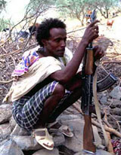 Courtesy of Ethiomedia
-“Ethiopian Rebels assume responsibility for volcano attack”

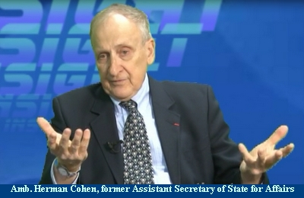Courtesy of ESAT.tv
-January 5, 2012 Herman Cohen says “Prime Minister Meles Government unstable; ‘Ethiopia’s incursion inside Eritrea territory’ was one of the reason for the war in 1998 between the two countries.”
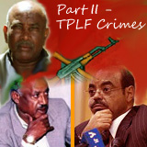Courtesy of ESAT.Tv
-Gebremedhin Araya digs into...‘Prime Minister Meles Zeawi’s and his cohorts ugly past and present and their crimes against humanity. ‘ESAT .Tv’
Courtesy of Ethiopian Government Satellite dish channel
-December 28, 20012 Expansionist Ethiopia big Deception... ‘The opposition is the one ...not us, who is for annexing Eritrea and take over Assab.’

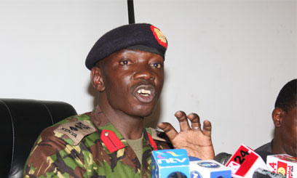
-January 16, 20012 ‘UN clears Eritrea, over the allegation of ‘arming Alshebab of Somalia’

Awet n’hafash!

