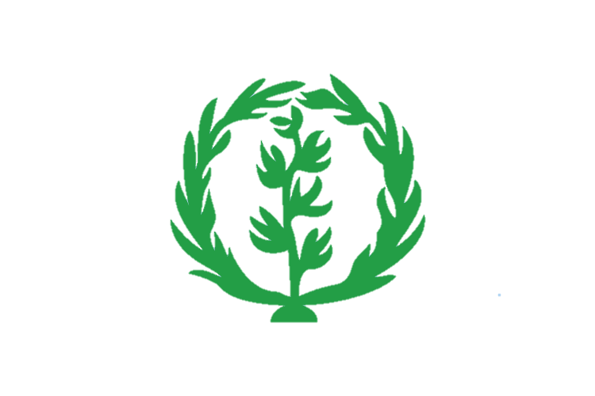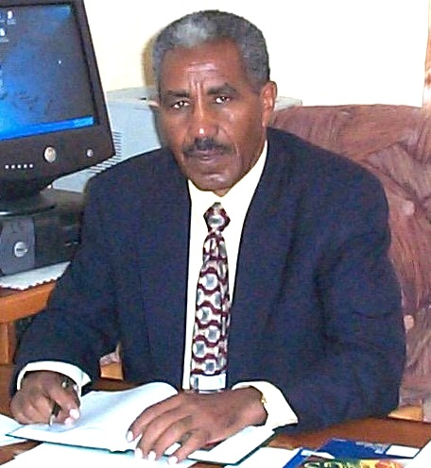

For More Information-

www.projectorotta.org ⎪ projectorotta@gmail.com

206.853.7372 ⎪ 206.375.9561⎪206.852.2459

Our mission is to assist in aiding the education and development of students in Eritrea by fundraising for education equipment.

**Project Orotta Fundraiser**

Support Eritrean Medical and Dental Students

Sunday ⎪ June 3rd ⎪ 3 PM

Eritrean Community Center

1954 S. Massachusetts St. ⎪Seattle 98144

Special Guest from Asmara:

DR. ANDEMARIAM ⎪ Dean of the Orotta Medical School